**SNS REPORT**

**NEEHAL PRAKASH BAJAJ(B20AI026)**

**RACHIT(B20AI032)**

**PROBLEM STATEMENT:**

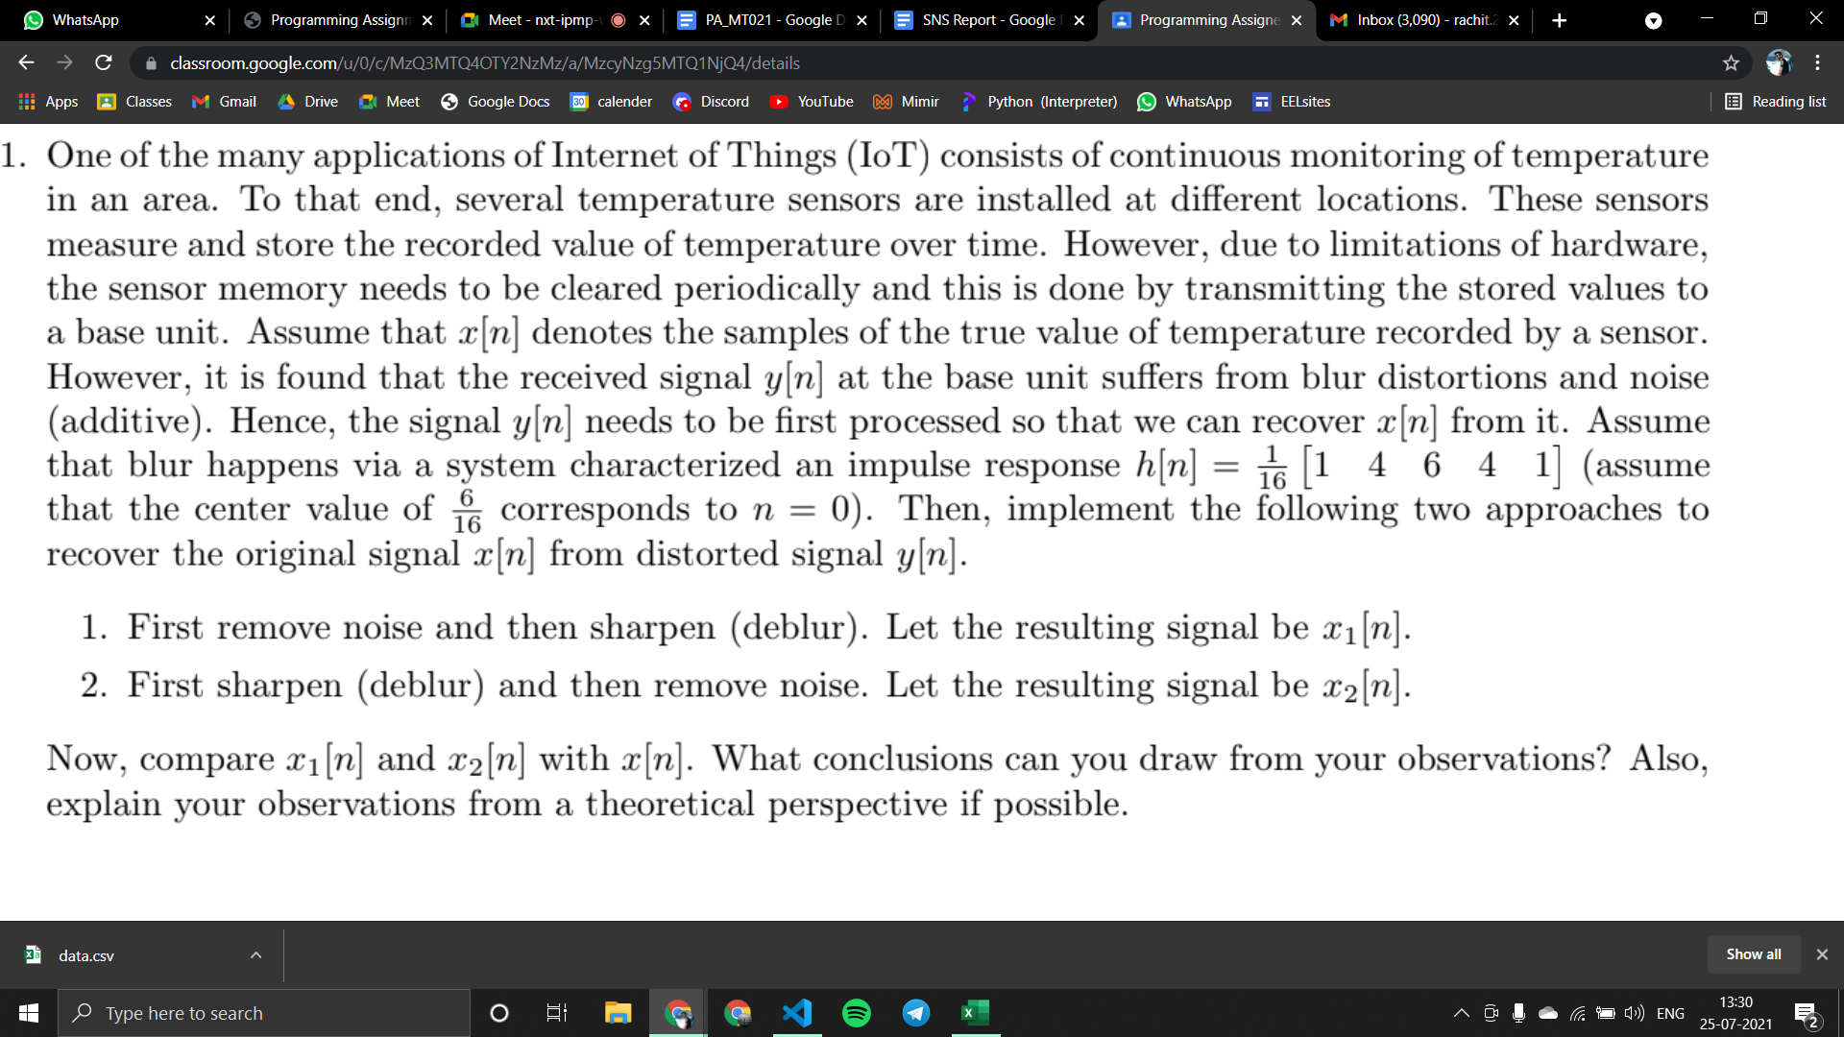

**AIM :**

We have been given y[n] and we have to find x[n], by two methods -

1. Denoising then Deblurring {X1[n]}
2. Deblurring then Denoise {X2[n]}

**Theory:**

* Denoising
* Denoising is any signal processing method which reconstructs a signal from a noisy one. Its goal is to remove noise and preserve useful information.
* We have taken average of 3 values for denoising
* avg= (y[i-1] + y[i] + y[i+1])/3
* For end values i.e. y[0] and y [192] we have used them twice in order to calculate the average of size 3.

* Deblurring
* Blurring can be understood as a low pass filter it blocks out high frequency components of a signal , which depends upon its impulse function.In the given problem the input function is h[n] = (1/16) * [ 1 4 6 4 1] where , n = 0 points to 6/16,n= 4 corresponds to ±1 and n=1 corresponds to ±2.

**Formulas:**

* Formulas used for fourier transform:
* 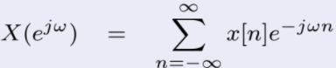
* For blurring a signal we convule with a kernel which is H[n] and for adding a noise we add a noisy signal.
* If we assume our signal to be x[n], output to be y[n], kernel to be h[n] and the noise signal be M. So y[n]= x[n]*h[n] + M.
* Now we need to find x[n] from y[n], for that we will use the formula of Fourier transform. Therefore,𝑌( $e^{jw}$) = 𝑋($e^{jw}$)𝐻($e^{jw}$) + M

𝑋(𝑒 𝑗𝑤 ) = {𝑌(𝑒 𝑗𝑤 ) / 𝐻(𝑒 𝑗𝑤 )} + M

* By applying inverse fourier transform we will get x[n]

**Graphs:**

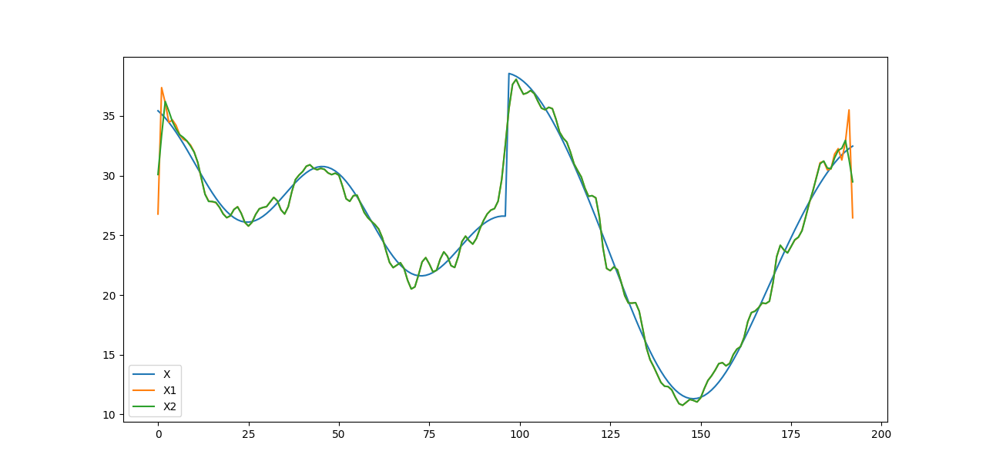

**EXCEL Explanation:**

Columns A,B,C show data of x1,x2,x respectively. Column F shows the difference between x1 & x i.e x1-x.

Column H corresponds to the absolute value of x1-x or elements of column F i.e |x-x1|.Similarly column K shows x-x2 and column I shows |x-x2|.

Thus column H ( |x-x1| ) and column I ( |x-x2| ) show the accuracy of signals x1 and x2 respectively;smaller the value more the accuracy.

Column M shows |x-x1| - |x-x2| if its <0 x1 will be more accurate because its difference is less thus being more accurate.

Column O shows sgn(M).

Cell O196 shows the sum of all cells in O because its negative x1 is a better approach.

**Conclusion:**

x1[n] and x2[n] look almost identical to the naked eye except the slight difference in endpoints. Although when we computed the data in excel we could clearly see x1 is more accurate and more close to the original signal x.Hence path 1 of denoising and then deblurring gives a more accurate result.

**Contribution:**

Constructive ideas and solving it together after a few wrong approaches was the key to completing the assignment.

**NEEHAL:**

* Made the readme.txt file.
* Sincerely gave time and patiently worked with the partner for various parts of the code.
* Contributed in making the report by using graphs and writing the theory part.

**RACHIT:**

* Made the Excel file.
* Sincerely gave time and patiently worked with the partner for various parts of the code.
* Contributed in making the report by using excel explanation and writing the theory part.

**\*\*\*\*\*\*\*\*\*\*\*\*\*\*\*\*\*\*\*THANK YOU\*\*\*\*\*\*\*\*\*\*\*\*\*\*\*\*\*\*\***